Ongoing Work

DataType in SysML
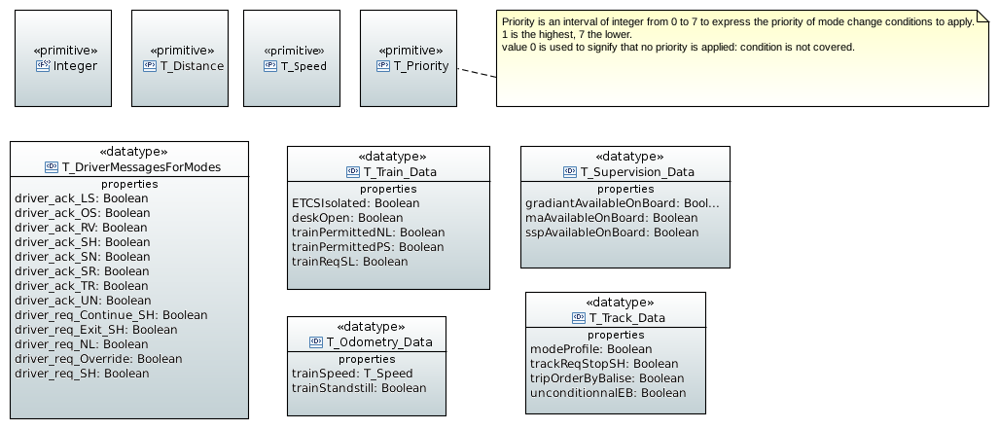

Inputs

From trackside
Name | Type | Description | Related req
Dist_level_transition | D_LEVEL_TR | Information issue from packet 41 | SRS-26 §5.10, 7.4.2.9, 7.4.2.11.2
Required_level_transition | M_LEVEL_TR | Information issue from packet 41 or 46 | SRS-26 §5.10, 7.4.2.9, 7.4.2.11.2
Id_NTC_level_transition | NID_NTC | Information issue from packet 41 or 46 | SRS-26 §5.10, 7.4.2.9, 7.4.2.11.2
Length_ack_level_transition | L_ACKLEVELTR | Information issue from packet 41 | SRS-26 §5.10, 7.4.2.9, 7.4.2.11.2
Dist_ma_mode | D_MAMODE | Information issue from packet 80  “The max safe front end of the train is inside the {OS/LS/SH} area” | SRS-26 §4.6, 5.7, 5.9, 5.19, 7.4.2.26
Available_ma_mode | M_MAMODE | Information issue from packet 80  “A mode profile for {OS/LS/SH} area has been received and is used” or “A mode profile for {OS/LS/SH} area is on-board” | SRS-26 §4.6, 5.7, 5.9, 5.19, 7.4.2.26
Speed_ma_mode | V_MAMODE | Information issue from packet 80  SRS-26 §5.19.3.2 “The speed is lower than the Limited Supervision mode speed limit (national value, or value given in the mode profile).” + 5.7.3.2 + 5.9.3.2 | SRS-26 §4.6, 5.7, 5.9, 5.19, 7.4.2.26
Length_ma_mode | L_MAMODE | Information issue from packet 80  “The max safe front end of the train is inside the {OS/LS/SH} area” | SRS-26 §4.6, 5.7, 5.9, 5.19, 7.4.2.26
Length_ack_ma_mode | L_ACKMAMODE | Information issue from packet 80  “An ackn. request for {OS/LS/SH} is displayed to the driver” | SRS-26 §4.6, 5.7, 5.9, 5.19, 7.4.2.26
Qualif_ma_mode | Q_MAMODE | Information issue from packet 80  Todo : used for mode management ? | SRS-26 §4.6, 5.7, 5.9, 5.19, 7.4.2.26
Dist_start_reversing_area | D_STARTREVERSE | Information issue from packet 138  SRS-26 §5.13.1.2 “The area where initiation of reversing will be possible is announced to the ERTMS/ETCS on-board equipment by trackside” | SRS-26 §4.6, 5.13, 7.4.2.34
Length_reverse_area | L_REVERSEAREA | Information issue from packet 138  SRS-26 §5.13.1.2 “The area where initiation of reversing will be possible is announced to the ERTMS/ETCS on-board equipment by trackside” | SRS-26 §4.6, 5.13, 7.4.2.34
 | D_REVERSE | Information issue from packet 138  Todo : used for mode management ?
 | L_REVERSE | Information issue from packet 138  Todo : used for mode management ?
Track_Req_stop_shunting | boolean | Packet 135 received | SRS-26 §4.6, 5.8, 7.4.2.31
Track_Req_stop_staff_resp | boolean | Packet 137 received | SRS-26 §4.6, 5.8, 7.4.2.31
 | V_NVSHUNT | National value by default or from packet 3  To compare to Speed_ma_mode  Todo : to clarify | SRS-26 §4.6, 7.4.2.1.1
 | V_NVSTFF | National value by default or from packet 3  Todo : to clarify | SRS-26 §4.6, 7.4.2.1.1
 | V_NVONSIGHT | National value by default or from packet 3  Todo : to clarify | SRS-26 §4.6, 7.4.2.1.1
 | V_NVLIMSUPERV | National value by default or from packet 3  Todo : to clarify | SRS-26 §4.6, 7.4.2.1.1
 | V_NVUNFIT | National value by default or from packet 3  Todo : to clarify | SRS-26 §4.6, 7.4.2.1.1
 | V_NVREL | National value by default or from packet 3  Todo : to clarify | SRS-26 §4.6, 7.4.2.1.1
 | D_NVROLL | National value by default or from packet 3  Todo : to clarify | SRS-26 §4.6, 7.4.2.1.1
 | V_NVALLOWOVERTRP | National value by default or from packet 3  Todo : to clarify | SRS-26 §4.6, 7.4.2.1.1
 | V_NVSUPOVTRP | National value by default or from packet 3  Todo : to clarify | SRS-26 §4.6, 7.4.2.1.1
 | D_NVOVTRP | National value by default or from packet 3  Todo : to clarify | SRS-26 §4.6, 7.4.2.1.1
 | T_NVOVTRP | National value by default or from packet 3  Todo : to clarify | SRS-26 §4.6, 7.4.2.1.1
 | D_NVPOTRP | National value by default or from packet 3  Todo : to clarify | SRS-26 §4.6, 7.4.2.1.1
 | D_NVSTFF | National value by default or from packet 3  Todo : to clarify | SRS-26 §4.6, 7.4.2.1.1
 | T_NVCONTACT |  | SRS-26 §4.6, condition [41]

Todo : Discuss if management of supervision fo balise in SH or SR mode (packet 49 and 63) is on the scope of supervision function or mode management. Inked to condition [52], [54] of SRS-26 § 4.6

From driver
Name | Type | Description | Related req
Level_from_driver | T_LEVEL | ERTMS/ETCS level | SRS-26 §4.6, 4.7.2, 5.10
Driver_start | Boolean | Start | SRS-26 §4.6, 4.7.2, 5.4
Driver_req_override | Boolean | Override request | SRS-26 §4.6, 4.7.2, condition [37]
Driver_req_SH | Boolean | Shunting request | SRS-26 §4.6, 4.7.2, condition [5, 35]
Driver_req_continue_SH | Boolean | “Continue Shunting on desk closure” request | SRS-26 §4.6, 4.7.2, condition [26, 27]
Driver_req_exit_SH | Boolean | “Exit of Shunting” request | SRS-26 §4.6, 4.7.2, condition [19]
Driver_req_NL | Boolean | Non Leading request | SRS-26 §4.6, 4.7.2, condition [46, 47]
Driver_ack_Level_tr | Boolean | Ackn of level transition | SRS-26 §4.6, 4.7.2, 5.10.4
Driver_ack_LS | Boolean | Ackn of Limited Supervision mode | SRS-26 §4.6, 4.7.2, condition [70]
Driver_ack_OS | Boolean | Ackn of On Sight mode | SRS-26 §4.6, 4.7.2, condition [15]
Driver_ack_SH | Boolean | Ackn of Shunting mode | SRS-26 §4.6, 4.7.2, condition [50]
Driver_ack_SR | Boolean | Ackn of Staff Resp. mode | SRS-26 §4.6, 4.7.2, condition [8]
Driver_ack_UN | Boolean | Ackn of Unfitted mode | SRS-26 §4.6, 4.7.2, condition [60]
Driver_ack_RV | Boolean | Ackn of Reversing mode | SRS-26 §4.6, 4.7.2, condition [59]
Driver_ack_SN | Boolean | Ackn of SN mode | SRS-26 §4.6, 4.7.2, condition [58]
Driver_ack_TR | Boolean | Ackn of Train Trip | SRS-26 §4.6, 4.7.2, condition [7, 62, 63, 68]
 | Boolean | Ackn for Post Trip distance exceeded (supervision ?) | SRS-26 §4.6, 4.7.2, SRS-26 § 3.14.1.7.4
 | Boolean | Ackn for reversing distance exceeded (supervision ?) | SRS-26 §4.6, 4.7.2, SRS-26 § 3.14.1.7.1
 |  | SR mode speed limit and distance (supervision ?) | SRS-26 §4.6, 4.7.2, SRS-26 § 3.11.7.1.3
 |  | Isolation  TODO :Clarify if the Driver isolate the on-board equipment by a switch (as describe in subset 034) or by a command on DMI | SRS-26 §4.6, 4.7.2, condition [1]

Desk/Train (subset-034)
Name | Type | Description | Related req
Train_req_SL | Boolean | Subset 034 :“The sleeping information is defined as a two state input with the following values:  - Sleeping requested  - Sleeping not requested.“ | Subset-034, SRS-26 §4.6, condition [3, 14]
Train_permitted PS | Boolean | Subset 034 :“The passive shunting information is defined as a two state input with the following values:  - Passive shunting permitted  - Passive shunting not permitted.” | Subset-034, SRS-26 §4.6, condition [26, 30]
Train_permitted_NL | Boolean | Subset 034 :“The non-leading information is defined as a two state input with the following values:  - Non-leading permitted  - Non-leading not permitted.” | Subset-034, SRS-26 §4.6, condition [46, 47]
ETCS_Isolated | Boolean | Subset 034 :“The isolation information is defined as a two state output with the following values:  - ETCS isolated  - ETCS not isolated.” | Subset-034, SRS-26 §4.6, condition [1]
Desk_open | Boolean | Subset 034 :“The cab status information is defined as a two state input with the following values:  - Cab active  - Cab not active.  Note 1: The cab status input is used by ERTMS/ETCS onboard for various purposes as defined in [1] or by an STM as defined in [3]. The expression "desk open" in [1] is equivalent to "Cab active" and "desk closed" in [1] is equivalent to "Cab not active".”  TODO: clarify for how many Cab/desk we need this information | Subset-034, SRS-26 §4.6, condition [2,…]
Direction_Controller | {Forward, Neutral, Backward} | “The direction controller information is defined as a three state input with the following values:  - Forward  - Neutral  - Backward.  The notion of forward direction shall correspond to the train orientation defined by the active (virtual) cab as defined in Error: Reference source not found, i.e. when the direction controller is in forward position, this means that the train movement will be in the direction of the active (virtual) cab.  If no cab is active the direction controller information may have any value, but shall be ignored by ERTMS/ETCS onboard.  Note: The direction controller input is used by ERTMS/ETCS onboard to prevent train movement which conflicts with the current position of the direction controller in the active cab and to detect the driver's intention to reverse, which is one of the conditions for entering Reversing mode. The direction controller input is also used by an STM as defined in [3].” | Subset-034, SRS-26 §5.13.1.4

From other functions
Name | Type | Description | Related req
Train_position |  | From calculate train position, structure ?
Train_speed |  | From odometer ?
Fault_detected |  | Fault detected by in-board, the system is going in system failure mode | SRS-26 §4.6, condition [13]
EOA_overpassed |  | From supervision , for trip mode | SRS-26 §4.6, condition [12, 16]

Missing data for the mode transition conditions SRS-26 §4.6
Name | Type | Description | Related req
Train_standstill | Boolean | Form the speed ? | SRS-26 §4.6, condition [3,…]
On-boardPowered | Boolean |  | SRS-26 §4.6, condition [4,29]
 |  | “The onboard reacts according to a linking reaction set to “trip”, “the train/engine receives and uses a trip order given by balise”, “unconditional emergency stop message is accepted” | SRS-26 §4.6, condition [17, 18, 20, 32]
 |  | “a National Trip Procedure is active” | SRS-26 §4.6, condition [35, 38]
 |  | “override” function is active” TODO maybe internal data | SRS-26 §4.6, condition [42, 46]
 |  | “The system version number X of a received balise telegram is greater than the highest version number X supported by the on-board equipment” | SRS-26 §4.6, condition [65]
 |  | “A balise group contained in the linking information is passed in the unexpected direction” | SRS-26 §4.6, condition [66]

Outputs
TODO

To trackside
Name | Type | Description | Related req

M_MODE (Packets 0, 1)
M_LEVEL (Packets 0, 1)
NID_NTC (Packets 0, 1)

To driver
Name | Type | Description | Related req

SRS-26 §4.7.2
ERTMS/ETCS Mode
Current ERTMS/ETCS level
Trip reason
Plain text information
Reversing allowed
Override status
Shunting refused by RBC
Shunting request not answered by RBC
Entry in FS/OS
Level transition announcement
SR mode proposed
OS/LS/SH mode proposed
SN mode proposed
UN mode proposed
RV mode proposed
Brake reason

Desk/Train (subset-034)
Name | Type | Description | Related req
EB_commanded | boolean | Subset 034 : “The emergency brake command (EBC) is defined as a two state output with the following values:  - Emergency brake commanded  - Emergency brake not commanded.” | Subset-034, SRS-26 §4 some modes request EB command

To other function
Name | Type | Description | Related req
Status_of_mission | {Start, End, On-going} | Information necessary to manage exchange with driver and RBC + storage of information | SRS-26 §5.4.3, SRS-26 §5.5.3.1

- Ask establishment of a communication session (see SRS-26 §3.4.2)
- Send position report at modes or levels change (SRS-26 §3.5.6.1.4)
- Selection of speed restriction depending on Modes ( SRS-26 § 3.10.2.2)

Internal
TODO
Name | Type | Description | Related req

- Current Level
- Current Mode
- Previous Level
- Previous Mode
- List of Required Level
- List of verified transition conditions

Architecture

High level
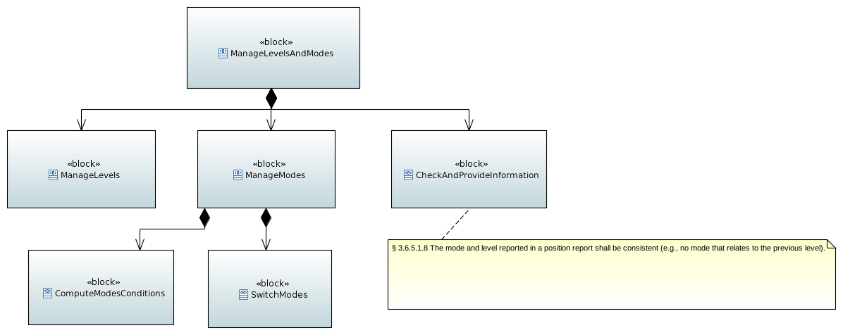
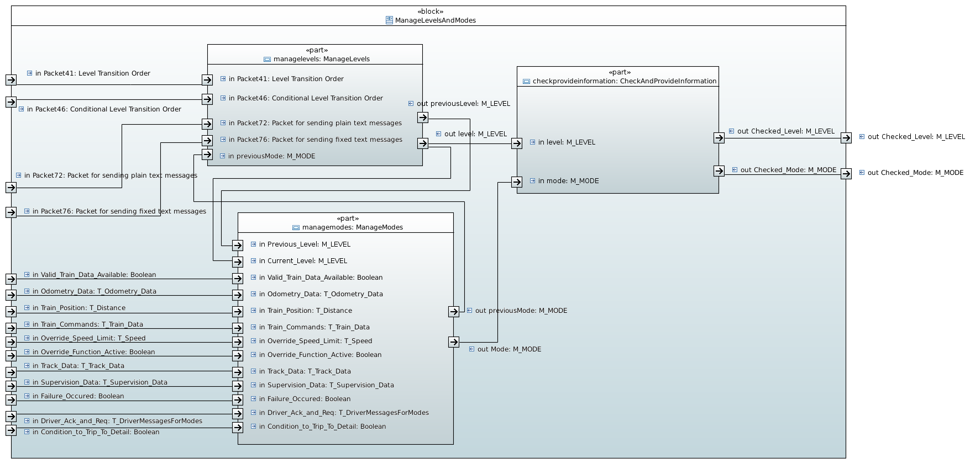

ProvideInformation

Description
TODO
- To provide level and mode to apply to other function
- To request EB ?
- To req message to send to driver
- To check that computed mode and Level are coherent (indeed, unfitted mode and Level 0) cf
3.6.5.1.8 | The mode and level reported in a position report shall be consistent (e.g., no mode that relates to the previous level).
Architecture of the function to clarify in function of the allocated tasks.
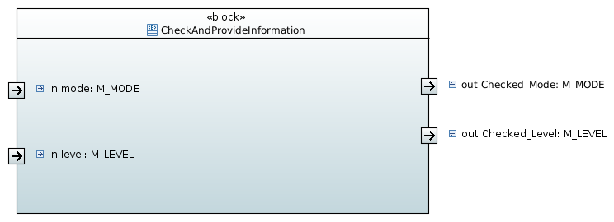

Inputs

Outputs

Requirements
SRS-26 § 3:
A set of requirements which needs mode or level information:.
3.5.2.4 | The on-board shall establish a communication session  - At Start of Mission (only if level 2 or 3).  - If ordered from trackside.  - If a mode change, not considered as an End of Mission, has to be reported to the RBC (only if level 2 or 3)  - If the driver has manually changed the level to 2 or 3  - When the train front reaches the end of an announced radio hole  - When the previous communication session is considered as terminated due to loss of safe radio connection (refer to 3.5.4.2.1)  - When a Start of Mission procedure, during which no communication session could be established, is completed in level 2 or 3
3.6.5.1.4 | The on-board equipment shall send position reports as requested by the RBC in the position report parameters. In addition, it shall also send a position report if at least one of the events listed hereafter occurs:  - The train reaches standstill, if applicable to the current mode.  - The mode changes.  - The driver confirms train integrity.  - A loss of train integrity is detected.  - The train passes a RBC/RBC border with its min safe rear end.  - The train passes a level transition border (from level 2/3 to level 0, NTC, 1) with its min safe rear end.  - The level changes.  - A communication session is successfully established.  - Intentionally moved.  - The train passes an LRBG compliant balise group (see 3.6.2.2.2), if no position report parameters are stored on-board.  - The train passes a RBC/RBC border with its max safe front end.
3.6.5.1.8 | The mode and level reported in a position report shall be consistent (e.g., no mode that relates to the previous level).
3.7.1.1 | To control the train movement in an ERTMS/ETCS based system the ERTMS/ETCS on-board equipment shall be given information from the trackside system both concerning the route set for the train and the track description for that route. The following information shall be given from the trackside  - Permission and distance to run, the Movement Authority (MA) (see section Error: Reference source not found)  - When needed, limitations related to the movement authority, i.e. Mode profile for On Sight, Limited Supervision or Shunting and signalling related speed restriction (see sections Error: Reference source not found and Error: Reference source not found). Mode profile and Signalling related Speed restriction shall always be sent together with the MA to which the information belongs  - Track description covering as a minimum the whole distance defined by the MA. Track description includes the following information  - The Static Speed Profile (SSP) (see section Error: Reference source not found).  - The gradient profile (see section Error: Reference source not found).  - Optionally Axle load Speed Profile (ASP) (see section Error: Reference source not found)  - Optionally Speed restriction to ensure a given permitted braking distance (see section 3.11.11)  - Optionally track conditions (see section Error: Reference source not found).  - Optionally route suitability data (see section Error: Reference source not found).  - Optionally areas where reversing is permitted (see section Error: Reference source not found).  - Optionally changed adhesion factor (see section Error: Reference source not found).  - Linking information when available.
3.11.7.1 | The value of the mode related speed restriction shall be determined by the corresponding national value or the corresponding default values if the national values are not applicable.
3.11.7.1.1 | Exception 1: For the modes On Sight, Limited Supervision and Shunting the speed limit can also be given from the trackside. The speed limit given from the trackside shall prevail over the National value and the default value
3.11.7.1.2 | Exception 2: For the mode Reversing there is no National/Default value. The speed limit is always given from trackside.
3.11.7.1.3 | Exception 3: For the mode Staff Responsible the speed limit can also be entered by the driver. The speed limit given by the driver shall prevail over the National/Default value.
3.12.3.4.2 | The following events can be used to define the start condition:  - Location  - Mode (start display as soon as in mode)  - Level (start display as soon as in level)
3.12.3.4.3 | The following events can be used to define the end condition:  - Location  - Time  - Mode (stop display when leaving mode)  - Level (stop display when leaving level)
3.14.1.3 | If the emergency brake command was triggered due to a trip condition (see chapter 4) the emergency brake command shall be released at standstill and after driver acknowledgement of the trip condition.
3.14.1.7.1 | If the brake command was triggered due to an overpassed reversing distance related to a reversing area or due to any further movement in the direction opposite to the train orientation while the reversing distance is still overpassed, the brake command shall be released if the reversing distance becomes extended so that the reversing distance is no longer overpassed, or at standstill after driver acknowledgement.
3.14.1.7.3 | If the brake command was triggered due to the detection of a train movement while modifying/revalidating train data or while entering SR speed/distance limits, the brake command shall be released at standstill and after driver acknowledgement..
3.14.1.7.4 | If the brake command was triggered due to an overpassed distance allowed for moving backwards in Post Trip mode or due to any further movement in the direction opposite to the train orientation while the distance allowed for moving backwards in Post Trip mode is still overpassed, the brake command shall be released at standstill and after driver acknowledgement.
3.15.1.3.3 | As soon as the on-board equipment has established the session with the Accepting RBC, it shall send its Train Data unless it is in sleeping or non leading mode.
3.15.3.1 | ERTMS/ETCS shall allow Splitting and Joining using the normal supervision functions available (e.g. On-sight, Shunting).
3.15.8.1 | After being switched off (i.e. once in No Power mode), the ERTMS/ETCS on-board equipment shall be capable, if fitted with, to detect and record whether the engine has been moved or not, during a period of at least 72 hours.
3.15.8.2 | When powered on again, the ERTMS/ETCS on-board equipment shall use, if available, the memorised information about cold movement in order to update the status of information stored by on-board equipment (see chapter 4 section 4.11 for details).
3.15.8.3 | Note: information memorised by Cold Movement Detection function is considered as not available if:  - no Cold Movement Detection function is implemented in the ERTMS/ETCS on-board equipment, OR  the Cold Movement Detection function has encountered a condition, during the No Power period, which prevents the use of the Cold Movement information (e.g. the battery ensuring the Cold Movement Detection function has run down during the No Power period).

ManageLevels

Description
TODO

Inputs- Outputs

Data | I/O | type | ok
announcement | I (BG/RBC) | transition information pos/level | x
announcement | O (DMI) | pos/level
level trans | I (BG) | conditional / immediate transition | x
position | I data | estimated front
train mode | I / data | current mode of train
MA | I (BG/RBC) | new MA after transitions | x
priority table | I (BG/RBC) | list of levels with prio | x
level | I / data | current level
mobile terminal | I / data | at least 1 terminal available
NTC system | I / data | National System X is available
selected lt | O (DMI) | level transition info
available level | O (DMI) | level information / selectable
contact order | I (BG) | message order | x
first section desc | I | MA + track desc / LOA | x?
train data | O (RBC) | ? | x
level report | O (DMI?) | level + position report | x?
terminate order | I (BG/RBC) | order to terminate comm session | x
message "no enter" | O (RBC) | msg won't enter announced RBC area
speed limit | I / data / ? | speed limit unequipped
position | I / data | min safe rear end
first section desc | I | MA (lvl 2/3) + track desc | x?
position report | O (RBC) | position report after transition | x
first section desc | I | MA (lvl 1) + track desc | x?
interface STM | I / data | bool
conditional lt | I |  | x?
level change manual | I (DMI) | level
contact info | I / data | id + tel number | x?
level change report | O (RBC) | level selection | x?
position | I | max safe front
ack poisition | I | position
driver ack | I (DMI) | level change ack from driver | x
service brake | O | de/activate service brake
train trip | O | train tripped

Requirements
SRS-26 § 3:
3.18.4.2.1 | The driver shall have the possibility to enter the ERTMS/ETCS level during a start of a mission.
3.18.4.2.2 | The ERTMS/ETCS level information is required for train operation except sleeping mode.
3.18.4.2.3 | In normal operation after the start of mission the driver shall not have to select the ERTMS/ETCS level (all other level transitions are executed automatically).
3.18.4.2.4 | For operational fallback situations: at standstill, the onboard equipment shall allow the driver to change the ERTMS/ETCS level..
3.18.4.2.5 | If the table of supported levels given by trackside is available, the selection of level by the driver shall be limited to those contained in this table. If the table of trackside supported levels is not available, the driver can select any level within a default list configured on-board.
3.18.4.3.2 | If the driver enters level 2/3, at start of mission, the ERTMS/ETCS on-board equipment shall offer the driver different means to select the RBC contact information (including RBC identity, RBC telephone number, and the identity of the radio network to be used), for details see chapter 5, Start of Mission procedure.
3.18.4.3.3 | In normal operation after the start of mission, the driver shall have no further possibility to modify the RBC contact information (all further modifications of this data are executed automatically). Exception: after a manual level change to level 2/3 and if either no Mobile Terminal is registered to a Radio Network or no valid RBC-ID/phone number is available, the ERTMS/ETCS on-board equipment shall request the driver to select the RBC contact information by the same means as for Start of Mission.

SRS-26 § 5.10:
To analyse

ManageModes
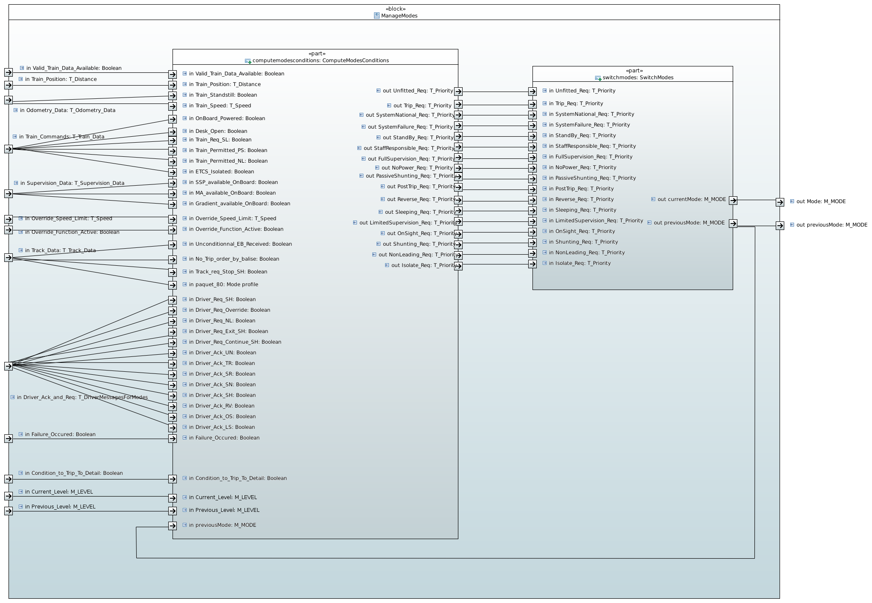

Compute Modes Conditions
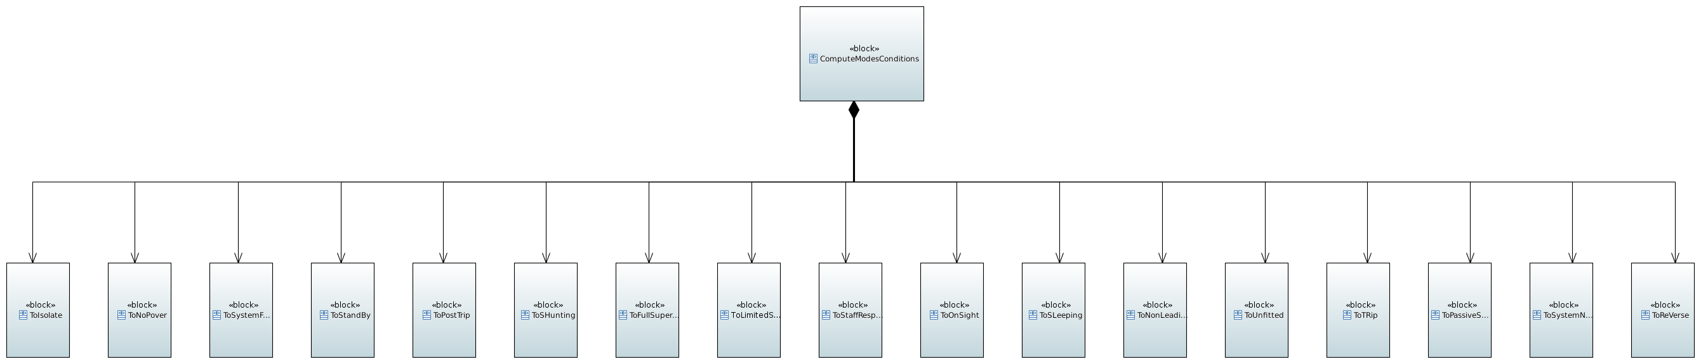
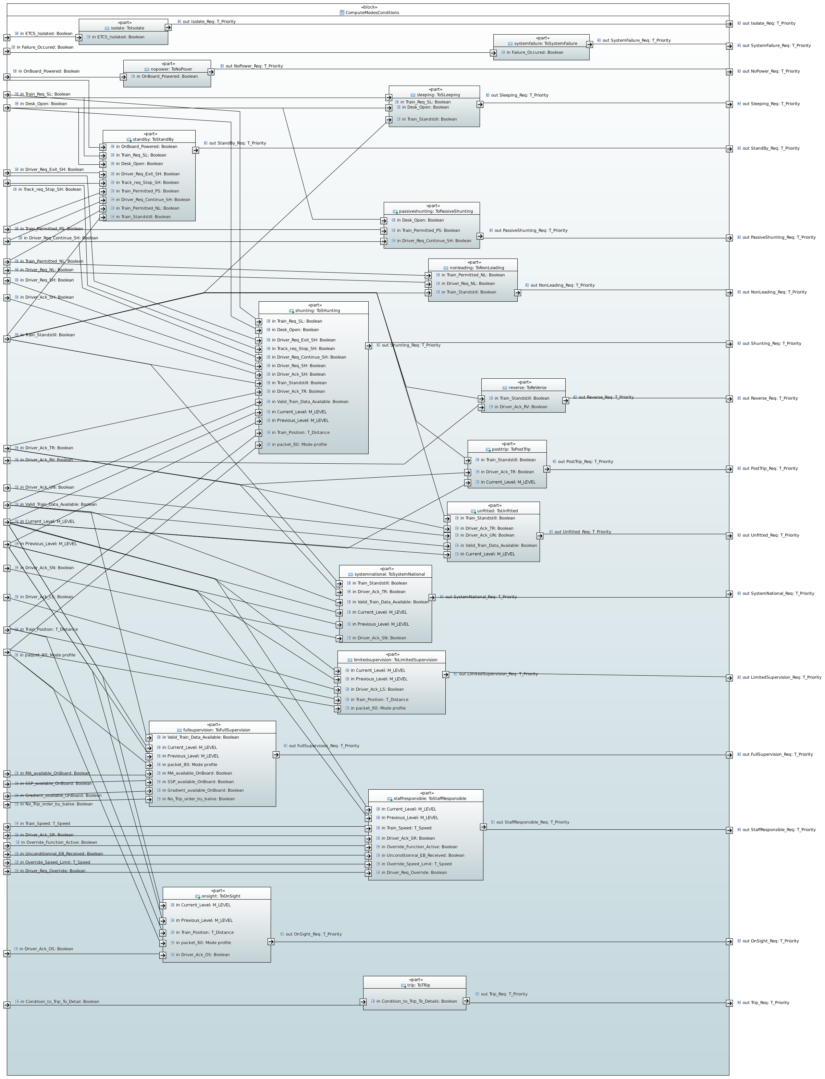

ToIsolate

Description
The Isolate Mode can be reached from any other mode with the highest priority.
To leave this mode a maintenance procedure is required.

Inputs
- ETCS_Isolated : Isolation request by the driver via Isolation Switch : interface with the train

Outputs
- Isolate_Req: priority 0 (not required) or 1 (required)

Requirements
SRS-26 § 4.4.3:
To analyse
SRS-26 § 4.6:
Condition Id | Content of the conditions
[1] | The driver isolates the ERTMS/ETCS on-board equipment.

ToNoPower

Description
The NoPower mode can be reached from all modes except Isolate

Inputs
- On-boardPowered : powered on of EVC

Outputs
- NoPower_Req : priority 0 (not required) or 2 (required)

Requirements
SRS-26 § 4.4.4:
To analyse
SRS-26 § 4.6:
Condition Id | Content of the conditions
[29] | the ERTMS/ETCS on-board equipment is NOT powered

ToSystemFailure

Description
SystemFailure mode can be reached from all modes except Isolate and NoPower.
From SystemFailure mode, the system can only switch to NoPower or Isolate modes.

Inputs
How are detected and reported Safety system failures?

Outputs

Requirements
SRS-26 § 4.4.5:
To analyse
SRS-26 § 4.6:
Condition Id | Content of the conditions
[13] | The ERTMS/ETCS on-board equipment detects a fault that affects safety

ToSleeping

Description
Sleeping mode can be reached from StandBy and PassiveShunting mode. It is related to the sleeping cab.

Inputs
- Desk_open: cabine is open or closed
- Train_standstill or Train_speed: clarify if we have to check the speed (which one ?) or if the Odometry management function provide ? how is store the information provided to DMI ?
- Train_req_SL: sleeping signal

Outputs

Requirements
SRS-26 § 4.4.6:
To analyse
SRS-26 § 4.6:
Condition Id | Content of the conditions
[14] | (The “sleeping” input signal is received) AND (train is at standstill) AND (all desks connected to the ERTMS/ETCS on-board equipment are closed)
SRS-26 § 5.5: procedure end of mission
To analyse
SRS-26 § 5.12: procedure change of train orientation
To analyse

ToStandBy

Description
StandBy mode is the default mode: it is selected at power-on and allow initialisation of train data.
It can be reached from all modes except Isolate, SystemFailure and Trip.
From standby mode the system can switch to all the modes except Passive shunting, PostTrip and reverse.

Inputs
- Desk_open: cabine is open or closed
- Train_standstill or Train_speed: clarify if we have to check the speed (which one ?) or if the Odometry management function provide ? how is store the information provided to DMI ?
- On-boardPowered : powered on of EVC
- Train_req_SL: sleeping signal
- Train_permitted PS : passive Shunting information (see subet 034)
- Train_permitted_NL: non leading information (see subset 034)
- Driver_req_continue_SH: “”Continue Shunting on desk closure” function is not active”
- Driver_req_exit_SH: “driver selects “exit Shunting””
- Track_Req_stop_shunting: ”Stop Shunting on desk opening” information is stored onboard “Driver_req_exit_SH

Outputs

Requirements
SRS-26 § 4.4.7:
To analyse
SRS-26 § 4.6:
Condition Id | Content of the conditions
[2] | (a desk is open)
[3] | (no “go sleeping” input signal is received any more) AND (train is at standstill)
[4] | The ERTMS/ETCS on-board equipment is powered.
[19] | (driver selects “exit Shunting”) AND (train is at standstill).
[22] | (a desk is open) AND (”Stop Shunting on desk opening” information is stored onboard)
[27] | (desks are closed) AND (”Continue Shunting on desk closure” function is not active)
[28] | (desks are closed)
[30] | (desks are closed) AND (no “passive shunting” input signal is received)
[47] | (no “non leading” input signal is received any more) AND (train is at standstill)
SRS-26 § 5.5: procedure end of mission
To analyse
SRS-26 § 5.12: procedure change of train orientation
To analyse

ToShunting

Description
To allow shunting movements, can be reached from SB, PS, FS, LS, SR, OS, UN, TR, PT, SN modes.

Inputs
- Desk_open: cabine is open or closed
- Train_standstill or Train_speed: clarify if we have to check the speed (which one ?) or if the Odometry management function provide ? how is store the information provided to DMI ?
- Current Level
- Previous Level
- Driver_req_SH
- Driver_ack_SH
- Train_req_SL: sleeping signal
- Driver_req_continue_SH: “”Continue Shunting on desk closure” function is not active”
- Driver_req_exit_SH: “driver selects “exit Shunting””
- Track_Req_stop_shunting: ”Stop Shunting on desk opening” information is stored onboard “
- Available_ma_mode
- Dist_ma_mode
- Length_ma_mode
- Train_position
- “no valid Train Data is on-board “Driver_req_exit_SH
- Driver_ack_TR

Outputs

Requirements
SRS-26 § 4.4.8:
To analyse
SRS-26 § 4.6:
Condition Id | Content of the conditions
[5] | (train is at standstill) AND (ERTMS/ETCS level is 0 or NTC or 1) AND (driver selects Shunting mode)
[6] | (train is at standstill) AND (ERTMS/ETCS level is 2 or 3) AND (reception of the information “Shunting granted by RBC”, due to a Shunting request from the driver)
[23] | (a desk is open) AND (no ”Stop Shunting on desk opening” information is stored onboard)
[50] | (An ackn. request for Shunting is displayed to the driver) AND (the driver acknowledges) see {5} here under
[51] | (A Mode Profile defining the entry of a Shunting area is used on-board) AND (The max safe front end of the train is inside the Shunting area)
[61] | (A Mode Profile defining a Shunting area is on-board) AND (The max safe front end of the train is inside the Shunting area) AND (The ERTMS/ETCS level switches to 1,2 or 3)
[68] | (the driver acknowledges the train trip) AND (the train is at standstill) AND (the ERTMS/ETCS level is 0 or NTC) AND (no valid Train Data is on-board)
{5} The request to acknowledge Shunting is displayed to the driver only if certain conditions are fulfilled. These conditions are not specified here. See the “Entry in Shunting” procedure and the “Start Of Mission” procedure of SRS-SRS-26 §5
SRS-26 § 5.4: procedure Start of mission
To analyse
SRS-26 § 5.5: procedure end of mission
To analyse
SRS-26 § 5.6: procedure shunting initiated by driver
To analyse
SRS-26 § 5.7: procedure shunting with order from trackside
To analyse
SRS-26 § 5.11: procedure train trip
To analyse
SRS-26 § 5.12: procedure change of train orientation
To analyse

ToFullSupervision

Description
Iti is a nominal mode in which all functions of supervision are activated in level 1, 2 or 3.
FullSupervision mode can be reached from SB, LS, SR, OS, UN, PT, SN modes.

Inputs
- “valid Train Data is stored on board”
- “MA + SSP +gradient are on-board”
- Available_ma_mode
- Current Level
- Previous Level
- “no trip order is given by balise”

Outputs

Requirements
SRS-26 § 4.4.9:
To analyse
SRS-26 § 4.6:
Condition Id | Content of the conditions
[10] | (valid Train Data is stored on board) AND (MA + SSP +gradient are on-board) AND (no specific mode is required by a Mode Profile)
[25] | (ERTMS/ETCS level switches to 1,2 or 3) AND (MA+SSP+gradient are on-board) AND (no specific mode is required by a Mode Profile)
[31] | (MA+SSP+gradient are on-board) AND (no specific mode is required by a Mode Profile) AND (ERTMS/ETCS level is 2 or 3)
[32] | (MA+SSP+gradient are on-board) AND (no specific mode is required by a Mode Profile) AND (ERTMS/ETCS level is 1) AND (no trip order is given by balise)
SRS-26 § 5.4: procedure Start of mission
To analyse
SRS-26 § 5.11: procedure train trip
To analyse

ToUnfitted

Description
Unfitted is the nominal mode associated to level 0. It can be reached from modes SB, FS, LS, SR, OS, Tr and SN.

Inputs
- Train_standstill or Train_speed: clarify if we have to check the speed (which one ?) or if the Odometry management function provide ? How is store the information provided to DMI ?
- Current Level
- Driver_ack_TR
- “valid Train Data is stored on board”
- Driver_ack_UN

Outputs

Requirements
SRS-26 § 4.4.10:
To analyse
SRS-26 § 4.6:
Condition Id | Content of the conditions
[21] | (ERTMS/ETCS level switches to 0) see {2} here under
[60] | (an acknowledgement request for UN mode is displayed to the driver) AND (the driver acknowledges)
[62] | (the driver acknowledges the train trip) AND (the train is at standstill) AND (the ERTMS/ETCS level is 0) AND (valid Train Data is on-board)
{2} This transition to the Unfitted mode is also a transition of level.. For further information, See the “Level Transition” procedure” (SRS-SRS-26 §5) for transitions from FS/SR/OS/LS to UN and the “Start Of Mission” procedure” (SRS-SRS-26 §5) for transition from SB to UN.
SRS-26 § 5.4: procedure Start of mission
To analyse
SRS-26 § 5.11: procedure train trip
To analyse

ToStaffResponsible

Description
StaffResponsible mode can be reached from SB, FS, LS, OS, UN, PT and SN modes.

Inputs
- Train_speed: clarify if we have to check the speed (which one ?) or if the Odometry management function provide ? how is store the information provided to DMI ?
- Current Level
- Previous Level
- Driver_ack_SR
- Driver_req_override
- “the speed limit for triggering the “override” function”
- “Override function is active”
- “Unconditional emergency stop message has been received”

Outputs

Requirements
SRS-26 § 4.4.11:
To analyse
SRS-26 § 4.6:
Condition Id | Content of the conditions
[8] | (Staff Responsible mode is proposed to the driver) AND (driver acknowledges) {4}
[37] | (driver selects “override”) AND (train speed is under or equal to the speed limit for triggering the “override” function) see {3} here under
[44] | (“override” function is active) AND (ERTMS/ETCS level switches to 1) see {3} here under
[45] | (“override” function is active) AND (no unconditional emergency stop message has been received) AND (ERTMS/ETCS level switches to 2 or 3) see {3} here under
{3} See the “Override” procedure” of SRS-SRS-26 §5.
{4} The Staff Responsible mode is proposed to the driver only if certain conditions are fulfilled. These conditions are not specified here. See the “Start Of Mission” procedure and the "Train Trip" procedure of SRS-SRS-26 §5.
SRS-26 § 5.4: procedure Start of mission
To analyse
SRS-26 § 5.11: procedure train trip
To analyse

ToOnSight

Description
On Sight mode can be reached from SB, FS, LS, SR, UN, PT, SN modes.

Inputs
- Driver_ack_OS
- Available_ma_mode
- Dist_ma_mode
- Length_ma_mode
- Length_ack_ma_mode
- Current Level
- Previous Level
- Train_position

Outputs

Requirements
SRS-26 § 4.4.12:
To analyse
SRS-26 § 4.6:
Condition Id | Content of the conditions
[15] | (An ackn. request for On Sight is displayed to the driver) AND (the driver acknowledges) see {1} here under
[34] | (A Mode Profile defining an On Sight area is on-board) AND (The max safe front end of the train is inside the On Sight area) AND (The ERTMS/ETCS level switches to 1,2 or 3)
[40] | (A Mode Profile defining an On Sight area is on-board) AND (The max safe front end of the train is inside the On Sight area)
[73] | (A Mode Profile defining an On Sight area is on-board) AND (The max safe front end of the train is inside the On Sight area) AND (The estimated front end of the train is not inside an LS acknowledgement area)
{1} The request to acknowledge On Sight is displayed to the driver only if certain conditions are fulfilled. These conditions are not specified here. See the “On Sight” procedure” of SRS-SRS-26 §5 (for transitions from FS/LS/UN to OS) and the "Start of mission" procedure (for transition from SB to OS).
SRS-26 § 5.4: procedure Start of mission
To analyse
SRS-26 § 5.9: procedure on sight
To analyse
SRS-26 § 5.11: procedure train trip
To analyse

ToTrip

Description
TODO

Inputs
TODO

Outputs

Requirements
SRS-26 § 4.4.13:
To analyse
SRS-26 § 4.6:
Condition Id | Content of the conditions
[12] | (The train/engine overpasses the EOA/LOA with its min safe antenna position) AND (ERTMS/ETCS level is 1)
[16] | (The train/engine overpasses the EOA/LOA with its min safe front end) AND (ERTMS/ETCS level is 2 or 3).
[17] | The onboard reacts according to a linking reaction set to “trip”.
[18] | (the train/engine receives and uses a trip order given by balise) AND (override is not active)
[20] | (unconditional emergency stop message is accepted)
[35] | (driver selects Shunting mode) AND (The ERTMS/ETCS on-board equipment is interfaced to the National System through an STM) AND (a National Trip Procedure is active, see {8} here under)
[36] | (the identity of the over-passed balise group is not in the list of expected balises related to SR mode) AND (override is not active).
[38] | (The ERTMS/ETCS on-board equipment is interfaced to the National System through an STM) AND (The ERTMS/ETCS level switches to 0,1,2 or 3) AND (a National Trip Procedure is active) see {8} here under
[39] | (The ERTMS/ETCS level switches to 1,2 or 3) AND (no MA has been accepted)
[41] | (T_NVCONTACT is passed) AND (associated reaction is “train trip”)
[42] | (The train/engine overpasses the SR distance with its estimated front end) AND (override is not active)
[43] | (The train/engine overpasses the former EOA (when Override was activated) with the min safe antenna position) AND (override is not active), see {3} here under
[49] | (reception of information “stop if in shunting”) AND (override is not active)
[52] | (the identity of the over-passed balise group is not in the list of expected balise groups related to SH mode) AND (override is not active).
[54] | (reception of information “stop if in Staff Responsible”) AND (no list of expected balise groups related to SR mode has been received or the list of expected balise groups related to SR mode does not include the identity of the over-passed balise group) AND (override is not active)
[65] | (The system version number X of a received balise telegram is greater than the highest version number X supported by the on-board equipment) AND (ERTMS/ETCS level is 1, 2 or 3)
[66] | A balise group contained in the linking information is passed in the unexpected direction
[67] | (The ERTMS/ETCS level switches to level 1) AND (a trip order has been received) AND (override is not active)
[69] | Estimated train front end is in rear of the start location of either SSP or gradient profile stored on-board
{8} Refer to Subset-035 for details.
SRS-26 § 5.11: procedure train trip
To analyse

ToPostTrip

Description
This mode can be reached only from trip mode, it allows to position the train in safe condition.

Inputs
- Train_standstill or Train_speed: clarify if we have to check the speed (which one ?) or if the Odometry management function provide ? How is store the information provided to DMI ?
- Current Level
- Driver_ack_TR

Outputs

Requirements
SRS-26 § 4.4.14:
To analyse
SRS-26 § 4.6:
Condition Id | Content of the conditions
[7] | (the driver acknowledges the train trip) AND (the train is at standstill) AND (the ERTMS/ETCS level is different from 0, NTC)
SRS-26 § 5.11: procedure train trip
To analyse

ToNonLeading

Description

Inputs
- Train_standstill or Train_speed: clarify if we have to check the speed (which one ?) or if the Odometry management function provide ? how is store the information provided to DMI ?
- Train_permitted_NL: non leading information (see subset 034)
- Driver_req_NL

Outputs

Requirements
SRS-26 § 4.4.15:
To analyse
SRS-26 § 4.6:
Condition Id | Content of the conditions
[46] | (Driver selects NON LEADING) AND (train is at standstill) AND (The “non leading” input signal is received)
SRS-26 § 5.4: procedure Start of mission
To analyse
SRS-26 § 5.12: procedure change of train orientation
To analyse

ToSystemNational

Description

Inputs
- Train_standstill or Train_speed: clarify if we have to check the speed (which one ?) or if the Odometry management function provide ? How is store the information provided to DMI ?
- Current Level
- Previous Level
- Driver_ack_TR
- “valid Train Data is stored on board”
- Driver_ack_SN

Outputs

Requirements
SRS-26 § 4.4.17:
To analyse
SRS-26 § 4.6:
Condition Id | Content of the conditions
[56] | (the ERTMS/ETCS level switches to “NTC”)
[58] | (the ERTMS/ETCS level is “NTC”) AND (an acknowledgement request for SN mode is displayed to the driver) AND (the driver acknowledges)
[63] | (the driver acknowledges the train trip) AND (the train is at standstill) AND (the ERTMS/ETCS level is NTC) AND (valid Train Data is on-board)
SRS-26 § 5.4: procedure Start of mission
To analyse
SRS-26 § 5.11: procedure train trip
To analyse

ToReverse

Description
The Reverse mode can be reached in Level 1, 2 or 3 from FS, LS or OS modes.

Inputs
- Train_standstill or Train_speed: clarify if we have to check the speed (which one ?) or if the Odometry management function provide ? How is store the information provided to DMI ?
- Driver_ack_RV

Outputs

Requirements
SRS-26 § 4.4.18:
To analyse
SRS-26 § 4.6:
Condition Id | Content of the conditions
[59] | (train is at standstill) AND (driver has acknowledged the reversing) see {6} here under
{6} The request to acknowledge Reversing is displayed to the driver when certain conditions are fulfilled. These conditions are not specified here. See the “reversing” procedure of SRS-SRS-26 §5.
SRS-26 § 5.13: procedure train reversing
To analyse

To LimitedSupervision

Description

Inputs
- Driver_ack_LS
- Available_ma_mode
- Dist_ma_mode
- Length_ma_mode
- Length_ack_ma_mode
- Current Level
- Previous Level
- Train_position

Outputs

Requirements
SRS-26 § 4.4.19:
To analyse
SRS-26 § 4.6:
Condition Id | Content of the conditions
[70] | (An ackn. request for Limited Supervision is displayed to the driver) AND (the driver acknowledges) see {7} here under
[71] | (A Mode Profile defining a Limited Supervision area is on-board) AND (The max safe front end of the train is inside the Limited Supervision area) AND (The ERTMS/ETCS level switches to 1,2 or 3)
[72] | (A Mode Profile defining a Limited Supervision area is on-board) AND (The max safe front end of the train is inside the Limited Supervision area).
[74] | (A Mode Profile defining a Limited Supervision area is on-board) AND (The max safe front end of the train is inside the Limited Supervision area) AND (The estimated front end of the train is not inside an OS acknowledgement area)
{7} The request to acknowledge Limited Supervision is displayed to the driver only if certain conditions are fulfilled. These conditions are not specified here. See the “Limited Supervision” procedure” of SRS-SRS-26 §5 (for transitions from FS/OS/UN to LS) and the "Start of mission" procedure (for transition from SB to LS).
SRS-26 § 5.4: procedure Start of mission
To analyse
SRS-26 § 5.11: procedure train trip
To analyse
SRS-26 § 5.19: procedure limited supervision
To analyse

To PassiveShunting

Description

Inputs
- Desk_open: cabine is open or closed
- Train_permitted PS : passive Shunting information (see subet 034)
- Driver_req_continue_SH: “”Continue Shunting on desk closure” function is not active”

Outputs

Requirements
SRS-26 § 4.4.20:
To analyse
SRS-26 § 4.6:
Condition Id | Content of the conditions
[26] | (desks are closed) AND (”Continue Shunting on desk closure” function is active) AND (the “passive shunting” input signal is received)
SRS-26 § 5.12: procedure change of train orientation
To analyse

SwitchMode

Description
This block is in charge to select the mode according conditions computed in “Compute Modes Conditions” block and priority defined in SRS-26 § 4.6.1.
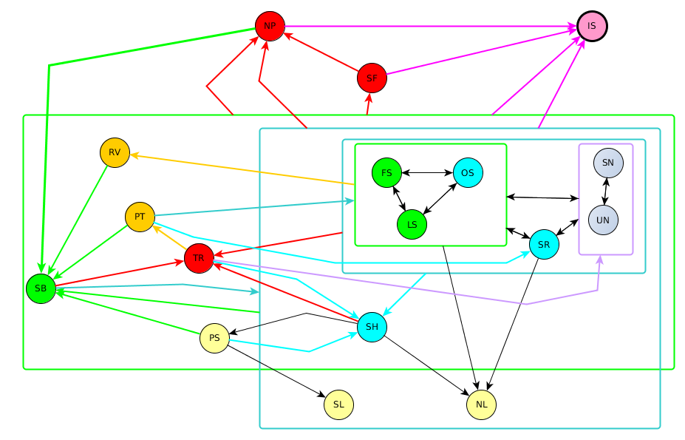
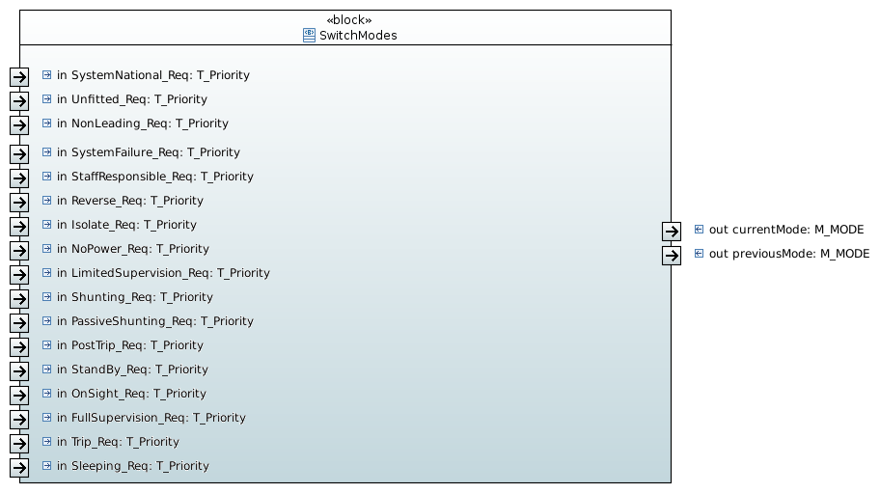

Inputs
The inputs are provided by “Compute Modes Conditions” block

Outputs
- Current Mode
- Previous Mode

Requirements

